User Guide for Direct Costs Calculators
This guide provides instructions for using the standard and simplified versions of the direct costs calculator.
The emphasis of this user guide is on the operation of the direct costs calculators. It does not focus on the process of identifying relevant compliance costs for a regulatory proposal. The following guidance note from the Commonwealth Office of Impact Analysis provides a useful overview of examples of direct compliance costs and how to estimate changes in regulatory burden.

When should the direct costs calculator to be used?
Agencies need to use the direct costs calculator to estimate the direct costs of compliance for individuals, businesses and community organisations impacted by the regulatory proposal. Direct compliance costs refer to administrative, delay and other substantive costs that entities may incur to comply with a regulation (refer Appendix 1). Direct compliance costs are a required field in the Summary Impact Analysis Statement (IAS) template.
The direct costs calculator is not designed to be used to estimate costs to government. Similarly, any other indirect social costs and transfers are excluded from this analysis. Where agencies are required to complete a full IAS, this must be accompanied by a comprehensive cost benefit analysis (CBA) that evaluates the total costs and total benefits of the regulatory proposal. While direct compliance costs will inevitably form part of a broader CBA, a complete CBA is beyond the scope of the direct costs calculators.

Standard direct costs calculator
The standard direct costs calculator replicates all the features of the web-based Commonwealth Regulatory Burden Measure (RBM), which is currently unavailable.

Summaries sheet
The ‘Summaries’ sheet presents the direct compliance cost estimates that agencies need to report in their IAS template. This sheet also displays disaggregated compliance cost estimates for each activity category (refer Appendix 1) and segment (individuals, businesses, and community organisations). Businesses and community organisations are also delineated by size (small, medium and large).
Other than specifying the number of years for the impact assessment and the discount rates for the base case and the sensitivity analysis, the user does not need to make any further changes in this sheet. The user can simply extract the relevant figures for the IAS template.

Individuals, Businesses and Community Organisations sheets
These three sheets operate in a similar manner. For each category and business/organisation size, the user needs to enter in the relevant inputs so that the total activity cost for each category can be calculated. The user can adjust the ‘Category’ and ‘Size’ filters in columns A and B to hide any unwanted sections.
Most activities are labour-based, but the precise information varies depending on the activity (for instance, the ‘Purchasing’ categories are not labour based – instead, the user simply needs to specify the number of times purchased per year and the purchase cost per activity). The required inputs differ depending on the category, but generally involve specifying the following:
- The number of individuals / businesses / community organisations affected by the activity
- The number of staff per business / community organisation affected by the activity (not relevant for individuals)
- Number of times the activity is performed per staff member each year
- The average time per staff member to complete the activity
- Hourly labour cost (incorporating wage and non-wage labour costs) –
  - note that all compliance costs are measured in real terms (i.e., hourly labour costs should not be adjusted over time to reflect economy-wide inflation)
  - where there are a range of staff on different salaries completing the same activity, the labour cost may reflect the weighted average of these hourly rates.
The user needs to enter this information for the desired number of years. Any years not required can be left blank.
By default, the IAS template measures compliance costs only for the first 10 years. It is open to agencies to justify a different timeframe if deemed appropriate. In the calculator, this setting is controlled by the ‘Number of years for impact assessment’ option on the ‘Summaries’ sheet. If the user adds information beyond the number of years set for this option, these costs will be ignored when generating the figures on the ‘Summaries’ sheet.
The spreadsheet then converts the annual costs to present values using the discount rates agencies specify in the ‘Summaries’ sheet.
Note: Consistent with the Commonwealth RBM, the first year of ongoing costs is incurred immediately, rather than at the end of the first year. This is a slightly different assumption from a conventional capital budgeting exercise.

Simplified direct costs calculator
The simplified direct costs calculator is a streamlined version of the standard model. As such, it has less flexibility than the standard model:
- There is no size distinction between small, medium, and large businesses and community organisations
- Ongoing costs are assumed to be constant each year, rather than having the flexibility to vary them by year
- There is a single labour cost assumption for the entire model (the standard model allows the user to change the labour cost depending on the cost category)
- Total number of years is the same throughout the model (in the standard model, it is possible for the user to assume, say, a 5-year period for some activities, but a 10-year timeframe for another activity)
It is open to agencies to use either the standard or simplified direct costs calculator depending on the requirements of their regulatory impact analysis, having regard to the limitations of the simplified calculator.

Inputs sheet (representative screenshot in Appendix 2)
This is the only sheet where the user needs to make changes. The user specifies the following general inputs:
- Labour cost ($/hour), incorporating both wage and non-wage costs
- Number of years for the assessment (again, the Summary IAS template specifies a 10-year period for direct compliance costs by default, but it is open to agencies to justify a different timeframe if appropriate)
- Discount rate (there is also a separate section for sensitivity analysis)
In the activity-specific inputs section of the sheet, the user will need to enter information about each activity category as required. For each category, there is the option of entering startup costs (one-off upfront costs) and ongoing costs.
Some of the cells in the ‘INDIVIDUALS’ columns are locked and shaded out as the ‘number of staff’ is not a relevant input for individuals.
As noted for the standard model, the first year of ongoing costs is incurred immediately, rather than at the end of the first year, consistent with the Commonwealth RBM. This is a slightly different assumption from a conventional capital budgeting exercise.

Summaries sheet (representative screenshot in Appendix 2)
The ‘Summaries’ sheet displays the direct compliance cost estimates that agencies need to report in their IAS, along with estimates for each activity category and segment (individuals, businesses, and community organisations).
The user does not need to make any changes in this sheet. The user can simply extract the relevant figures as required for their assessment.

Other sheets
In the simplified model, the user does not need to interact with the ‘Individuals’, ‘Businesses’ or ‘Community Organisations’ sheets. All relevant estimates are captured in the ‘Summaries’ sheets.

Appendix 1: Full list of activity costings
Compliance cost category | Description | Example
Notification | Notification: businesses face costs when they have to report certain events to a regulatory authority, either before or after the event has taken place. | A business needs to notify a public authority before they are permitted to sell food.
Education | Education: businesses face costs when keeping up to date with regulatory requirements. | A business needs to get the details of new legislation and communicate the new requirements to staff.
Permission | Permission: businesses face costs when applying for and maintaining permission to conduct an activity. | A business needs to do a police check before employing staff legally.
Purchasing | Purchasing: businesses face costs when having to purchase a service (advice) or a product (materials or equipment) to comply with a regulation. | A business needs to get legal advice (service), complete a periodic audit (service), have a fire extinguisher onsite (product), purchase environmental offsets or carbon credits (product).
Record keeping | Record keeping: businesses face costs to keep statutory documents up to date. | A business needs to keep records of accidents that happen at their workplace.
Enforcement | Enforcement: businesses face costs when cooperating with audits, inspections and regulatory enforcement activities. | A business needs to supervise a government inspector when the inspector checks whether a business meets non-smoking laws.
Publication and documentation | Publication and documentation: businesses face costs when having to produce documents for third parties. | A business needs to display warning signs around dangerous equipment, or a sign at the entrance to home-based business premises.
Procedural | Procedural: businesses face non-administrative costs imposed by some regulations. | A business needs to conduct a fire safety drill several times a year.
Delay | Delay: businesses face costs when administrative delays result in expenses and loss of income. | A business needs to wait for an application to be approved before it can begin trading, causing it to forgo the opportunity to earn profits in that time
Other | Other: any other direct compliance cost faced by business that doesn't fit into one of the above categories.
Note: With the exception of delay costs, direct compliance costs do not include opportunity costs.

Appendix 2: Screenshots for simplified calculator

Inputs sheet in Simplified Direct Costs Calculator
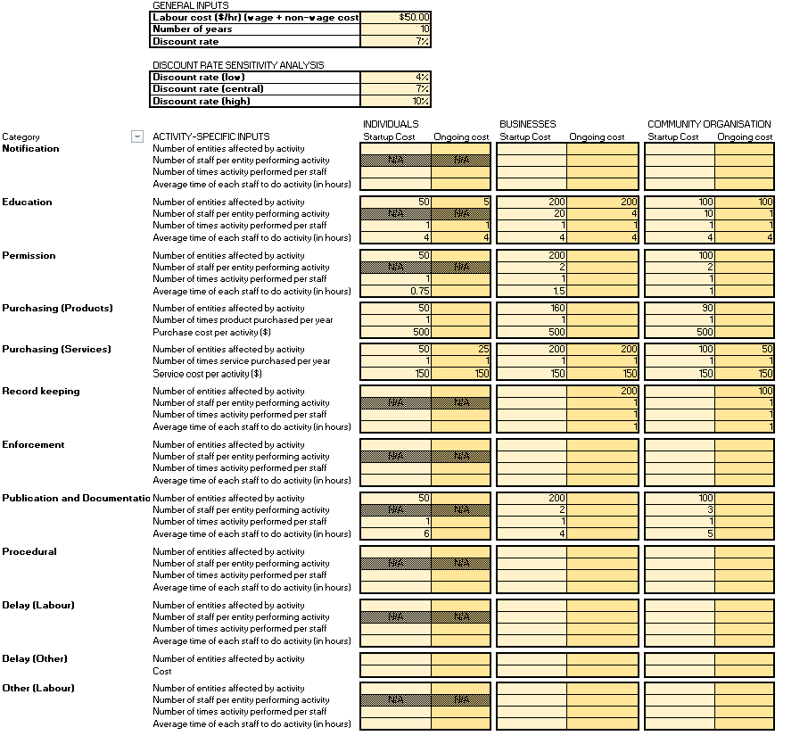

Summaries sheet in Simplified Direct Costs Calculator
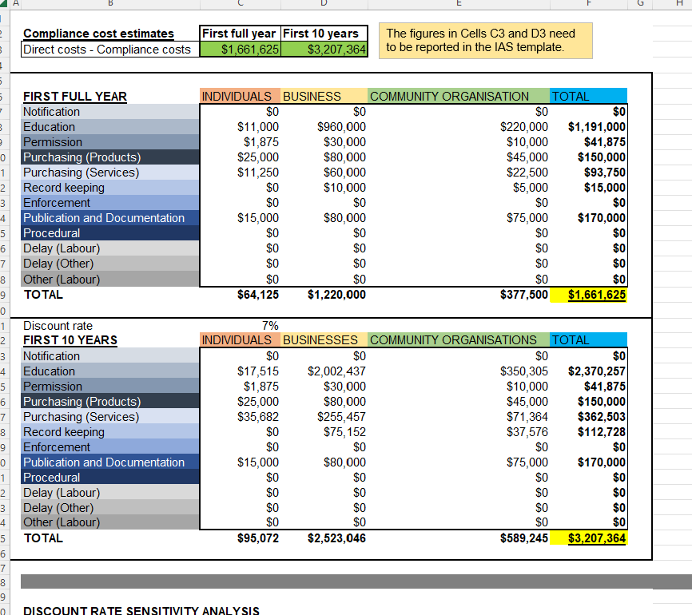

This guidance note is for background purposes only; Queensland agencies should disregard any references to Commonwealth policies, templates or reporting requirements
A discount rate converts expected future cash flows into a present value to enable comparison at a single point in time. For further information on discount rates, please refer to Section B3 of Queensland Treasury’s cost-benefit analysis guidance materials for the Project Assessment Framework (https://s3.treasury.qld.gov.au/files/paf-cost-benefit-analysis.pdf)
Sensitivity analysis examines how financial and economic outcomes change when specific assumptions are adjusted. For further information on sensitivity analysis, please refer: https://s3.treasury.qld.gov.au/files/paf-cost-benefit-analysis.pdf
Cells that do not require editing will be locked, but the user will be able to unprotect the sheet without requiring a password.
Enforcement activities assume full compliance with the proposed regulation. The direct cost calculator does not account for penalties or legal enforcement due to non-compliance.

